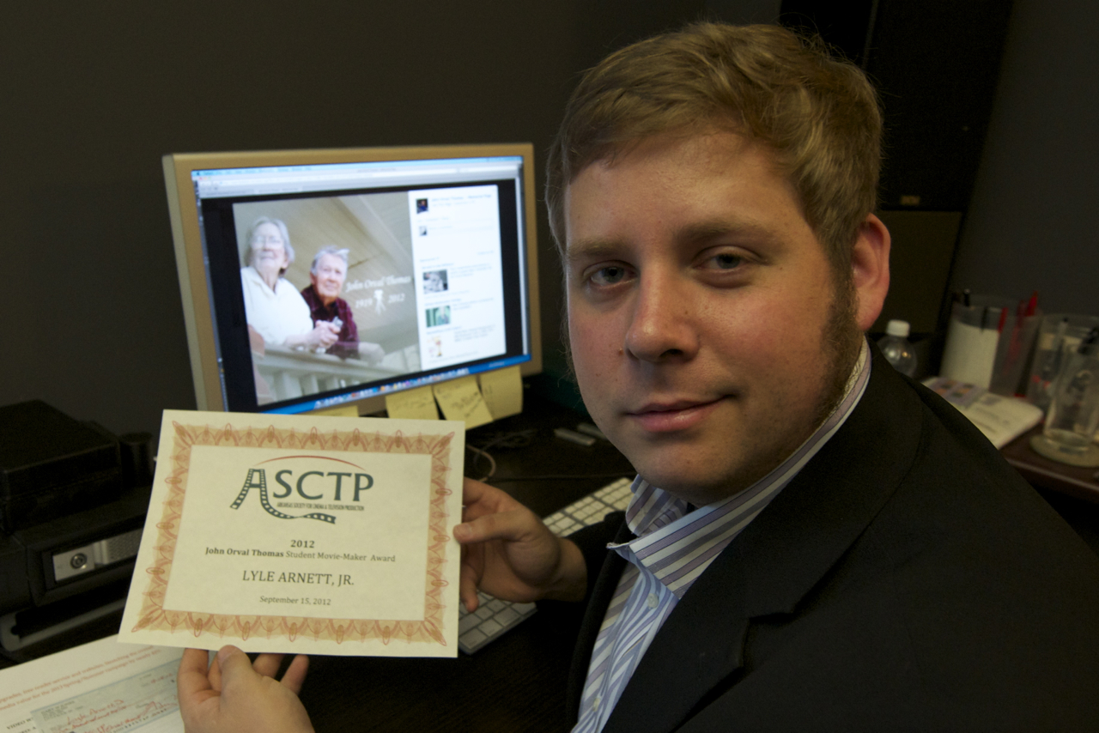

For Immediate Release

University of Central Arkansas Digital Filmmaking graduate student Lyle Arnett, Jr. of Texarkana received the 2012 John Orval Thomas Student Movie-making Award. The $500 cash award was presented by the Arkansas Society for Cinema & Television Production (ASCTP) in honor of venerated Arkansas cinematographer Orval Thomas, who died August 31st at age 92.
Arnett reports that he will apply the award to the completion of his UCA master’s degree thesis film “December 1982”.
The ASCTP is a non-profit organization that has been supporting motion picture educational initiatives among young Arkansas filmmakers—“movie-makers” is the term Orval preferred—since 2005.

