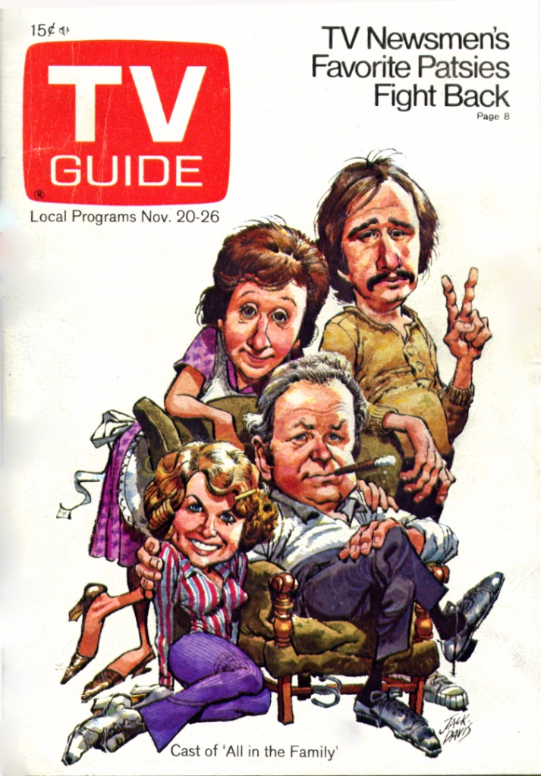

I started working at KAIT-TV on July 1, 1963, a few days after my 17th birthday. When this article was published eight years later, TV GUIDE had over 20 million readers and was one of the most widely-read magazines in the U.S. (This was before the day of cable networks and local newspaper television guides.)

They paid me $450 for the article, which was not a bad payday in 1971. The money went immediately for wine, women, and song. The rest wasted. (rimshot)

Fifty years later I'm finally getting around to working on the follow-up article.

